**PRACTICAL 11**

**Aim:** To create the following topology:

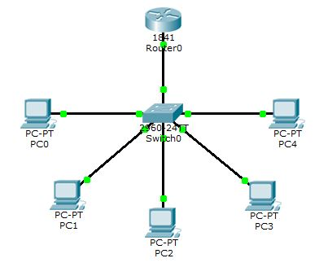

**PC0:**

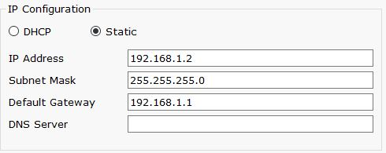

**PC1:**

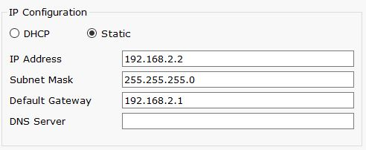

**PC2:**

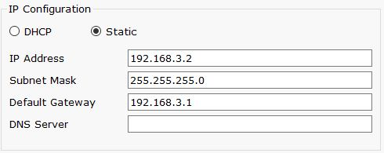

**PC3:**

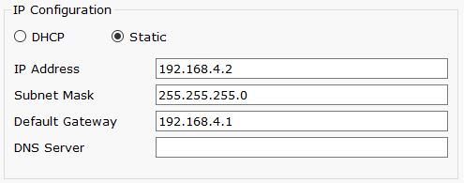

**PC4:**

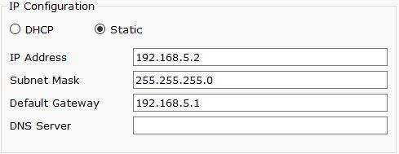

**Switch0:**

Switch>en

Switch#config t

Enter configuration commands, one per line. End with CNTL/Z.

Switch(config)#int fa0/1

Switch(config-if)#switchport mode access

Switch(config-if)#switchport access vlan 2

% Access VLAN does not exist. Creating vlan 2

Switch(config-if)#no shut

Switch(config-if)#exit

Switch(config)#int fa0/2

Switch(config-if)#switchport mode access

Switch(config-if)#switchport access vlan 3

% Access VLAN does not exist. Creating vlan 3

Switch(config-if)#no shut

Switch(config-if)#exit

Switch(config)#int fa0/4

Switch(config-if)#switchport mode access

Switch(config-if)#switchport access vlan 4

% Access VLAN does not exist. Creating vlan 4

Switch(config-if)#switchport access vlan 5

% Access VLAN does not exist. Creating vlan 5

Switch(config-if)#no shut

Switch(config-if)#exit

Switch(config)#int fa0/3

Switch(config-if)#switchport mode access

Switch(config-if)#switchport access vlan 4

Switch(config-if)#no shut

Switch(config-if)#exit

Switch(config)#int fa0/5

Switch(config-if)#switchport mode access

Switch(config-if)#switchport access vlan 6

% Access VLAN does not exist. Creating vlan 6

Switch(config-if)#no shut

Switch(config-if)#exit

Switch(config)#interface FastEthernet0/6

Switch(config-if)#

Switch(config-if)#switchport mode trunk

Switch(config-if)#

%LINEPROTO-5-UPDOWN: Line protocol on Interface FastEthernet0/6, changed state to down

%LINEPROTO-5-UPDOWN: Line protocol on Interface FastEthernet0/6, changed state to up

Router>en

**Router0:**

Router#config t

Enter configuration commands, one per line. End with CNTL/Z.

Router(config)#int fa0/0.1

Router(config-subif)#encapsulation dot1Q 2

Router(config-subif)#ip address 192.168.1.1 255.255.255.0

Router(config-subif)#no shut

Router(config-subif)#exit

Router(config)#int fa0/0.2

Router(config-subif)#encapsulation dot1Q 3

Router(config-subif)#ip address 192.168.2.1 255.255.255.0

Router(config-subif)#no shut

Router(config-subif)#exit

Router(config)#int fa0/0.3

Router(config-subif)#encapsulation dot1Q 4

Router(config-subif)#ip address 192.168.3.1 255.255.255.0

Router(config-subif)#no shut

Router(config-subif)#exit

Router(config)#int fa0/0.4

Router(config-subif)#encapsulation dot1Q 5

Router(config-subif)#ip address 192.168.4.1 255.255.255.0

Router(config-subif)#no shut

Router(config-subif)#exit

Router(config-subif)#int fa0/0.5

Router(config-subif)#encapsulation dot1Q 6

Router(config-subif)#ip address 192.168.5.1 255.255.255.0

Router(config-subif)#no shut

Router(config-subif)#exit

Router(config)#int fa0/0

Router(config-if)#no shut

Router(config-if)#

%LINK-5-CHANGED: Interface FastEthernet0/0, changed state to up

%LINEPROTO-5-UPDOWN: Line protocol on Interface FastEthernet0/0, changed state to up

%LINK-5-CHANGED: Interface FastEthernet0/0.1, changed state to up

%LINEPROTO-5-UPDOWN: Line protocol on Interface FastEthernet0/0.1, changed state to up

%LINK-5-CHANGED: Interface FastEthernet0/0.2, changed state to up

%LINEPROTO-5-UPDOWN: Line protocol on Interface FastEthernet0/0.2, changed state to up

%LINK-5-CHANGED: Interface FastEthernet0/0.3, changed state to up

%LINEPROTO-5-UPDOWN: Line protocol on Interface FastEthernet0/0.3, changed state to up

%LINK-5-CHANGED: Interface FastEthernet0/0.4, changed state to up

%LINEPROTO-5-UPDOWN: Line protocol on Interface FastEthernet0/0.4, changed state to up

%LINK-5-CHANGED: Interface FastEthernet0/0.5, changed state to up

%LINEPROTO-5-UPDOWN: Line protocol on Interface FastEthernet0/0.5, changed state to up

Router(config-if)#exit

**Output:**

